


City Weather Information

Today we will look for weather information on your city.
- Open Internet Explorer (look for the Blue e: ).
- Find the ADDRESS BAR. Type in the URL just like below.
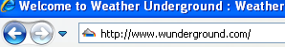
- Type in the name of your city that your teacher assigned you.
- Find the following information in the Current Conditions box:
Current Temperature
Current Conditions
(roll your mouse over the picture)
Current Wind Speed
Wind Direction
Humidity
